Illinois Active Community Care Transition Project Request for Information and Request for Application

Request for Information
TheRequestforApplicationfollowsthissection.

Date Submitted: Please Check One Original Revision
Agency Name:
Address:
Contact Person for RFI Responses:
Contact Office Number:
Contact Cell Number:
Contact email Address:
Other Contact Info:
Agency Website:
Counties Currently Served:
Current Services | #
Total number of people served
Number who have Intellectual and Other Developmental Disabilities
Number of people not included above that have an Autism Spectrum Disorder

Estimated number of above individuals who would be described as having: | #
Borderline intellectual disability
Mild or minimal disabilities - Needs intermittent supports
Moderate disabilities - Needs limited supports
Severe disabilities - Needs extensive supports
Profound disabilities - Needs pervasive ongoing and intensive supports
Estimated number of people who also have: (numbers can be duplicated) | #
Mental illness
Severe behavioral challenges
Significant medical problems
Mobility challenges
Significant communication problems
Toileting needs
Eating or food consumption support needs
Aggression
Self-injury
Sexuality related issues
Forensic issues (criminal charges, history of illegal behavior)

Illinois ACCT Project Request for Information and Request for Application Forms
– Working DRAFT

Estimated number of people served residentially in: | #
Shared Living situations (two-three people sharing a home)
Supported living arrangements (their own home or apartment)
Settings of 4 or fewer people (not included above)
Settings of 5 or more people
Estimated number of people served vocationally in: | #
Traditional pre-vocational congregate settings
Traditional workshop settings (not included above)
Enclave settings
Mobile work crews
Supported employment
Competitive employment
Micro-enterprises (not included above)
Not engaged in day services (not included above)

On a scale of 1 to 5, with 1 being very limited competency or experience and 5 being high level of competency or experience please rate your organization's experience/competency with the following items/skills:
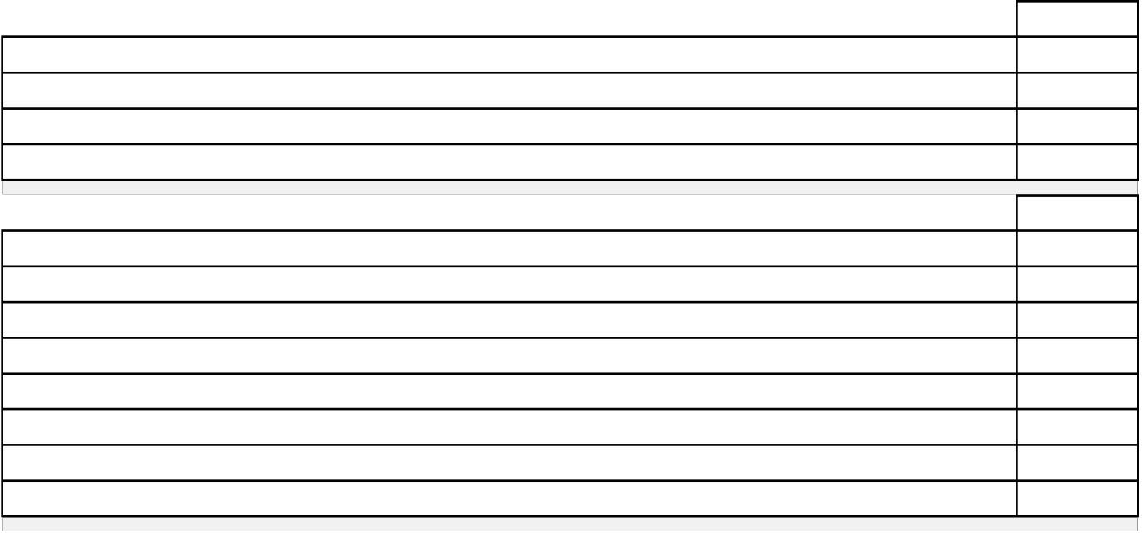

Positive Behavior Supports
Dual Diagnosis (MI/IDD)
Providing housing services/developing housing (not providing the services)
Providing residential support services but not providing the housing
Providing the following types of assessments:
Medical
Dental
Psycho-pharmacologic
Psychiatric
Psychological
Psycho-Social
Communication
Physical Therapy
Occupational Therapy
Sensory Integration
Functional Behavioral Assessments
Providing the following types of services:
Medical
Dental
Psycho-pharmacologic
Psychiatric
Psychological
Psycho-Social
Communication
Physical Therapy
Occupational Therapy

– Working DRAFT
On a scale of 1 to 5, with 1 being very limited competency or experience and 5 being high level of competency or experience please rate your organization's experience/competency with the following items/skills:
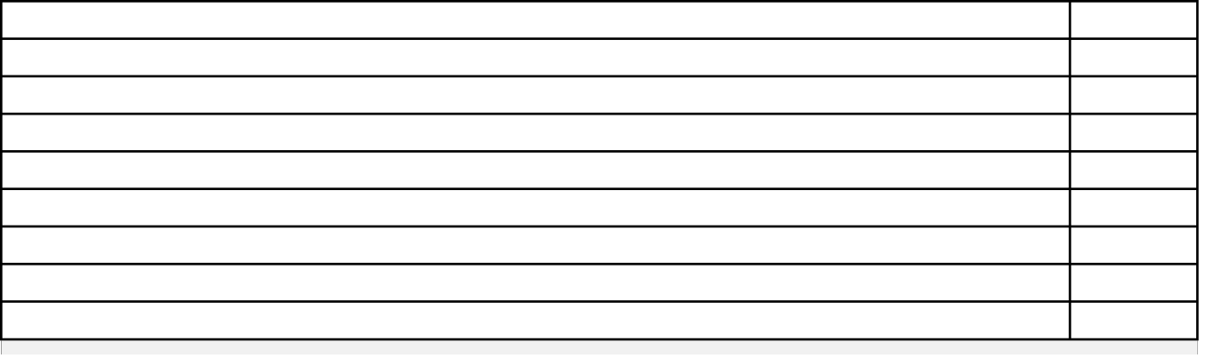

Providing the following types of services:
Sensory Integration
Positive Behavior Supports
Facility-Based Crisis Services
Mobile Crisis Services
Crisis Respite
Collaboration with community organizations
Supporting Self-Advocacy
Working with Micro-Boards
For many reasons, some agencies, by policy or practice, do not typically work with people have certain behaviors or diagnoses. Please indicate below with an X in the box, any behaviors or diagnoses that your agency typically does not work with.
Borderline intellectual disability
Mild or minimal disabilities - Needs intermittent supports
Moderate disabilities - Needs limited supports
Severe disabilities - Needs extensive supports
Profound disabilities - Needs pervasive supports
Mental illness
Severe behavioral challenges
Significant medical problems
Mobility challenges
Significant communication problems
Toileting needs
Feeding needs
Aggression
Self-injury
Sexuality related issues
Forensic issues (criminal charges, history of illegal behavior)
On a scale of 1 to 5, with 1 being very poor and 5 being very positive, please rate your access to the following services.
Medical, including hospitals and General Practitioners/Primary Care providers
Dental
Psycho-pharmacologic
Psychiatric
Psychological
Psycho-Social
Communication
Physical Therapy
Occupational Therapy
Sensory Integration
Positive Behavior Supports

– Working DRAFT
Please estimate the number of people your organization has assisted to transition from SODC's to
services you provide in the past 5 years .
Please estimate the number of the people identified above that have been successful in their
transition.
Please provide the top three reasons you believe people have not been successful with their transition to your services in the community from SODCs
1
2
3
Please provide the top three reasons you believe people were successful with their transition to your services in the community from SODCs
1
2
3
Please estimate the total number of the people that your organization has sent to an SODC in the
past 5 years.
Please provide the top three reasons you believe people needed to go to an SODC for services.
1
2
3
Additional comments are welcome.
If submitting electronically, please add comments to the last page of this form.

Illinois ACCT Project Request for Information and Request for Application Forms
– Working DRAFT

Request for Application
ThisformshouldbesubmittedasanattachmenttoyourcompletedRequestforInformation.

Date Submitted: Please Check One Original Revision
Agency Name:
Address:
Contact Person for RFA Responses:
Contact Office Number:
Contact Cell Number:
Contact email Address:
Counties We Would Consider Expanding To:
The responses that follow will serve as an indication of your organization's interest and perceived competence at addressing specific issues associated with transition, including
specific disabilities, staff skills, organizational values and practices, and community engagement.

Assuming that you are provided sufficient resources to expand services appropriately, on a per person basis, please estimate the number of additional
people you believe you can support within the next year.>>
Of the people you have said you could serve with expansion support above, people who have which of the following types of disability are you able and willing to assist?
Please check all that apply.
Autism Spectrum Disorders
Borderline intellectual disability
Mild or minimal disabilities - Needs intermittent supports
Moderate disabilities - Needs limited supports
Severe disabilities - Needs extensive supports
Profound disabilities - Needs pervasive supports
Mental illness
Severe behavioral challenges
Significant medical problems
Mobility challenges
Significant communication problems
Toileting needs
Feeding needs
Aggression
Self-injury
Sexuality related issues
Forensic issues (criminal charges, history of illegal behavior)

– Working DRAFT

For the people you said above that you could serve with expansion support, which of the following types of service are you able and willing to develop (with needed assistance)?
Individual setting for single person (requiring a variety of supports, up to 24/7)
Shared Living situations (two-three people sharing a home)
Supported living arrangements (their own home or apartment)
Settings of 4 or fewer people
Supported employment
Competitive employment
Micro-enterprises (not included above)
Individualized non-work/community-based day services
Positive Behavior Supports
Dual Diagnosis (MI/IDD)
Providing housing services/developing housing (not providing the services)
Providing residential support services but not providing the housing
Providing the following types of assessments:
Medical
Dental
Psycho-pharmacologic
Psychiatric
Psychological
Psycho-Social
Communication
Physical Therapy
Occupational Therapy
Sensory Integration
Functional Behavioral Assessments
Providing the following types of services:
Medical
Dental
Psycho-pharmacologic
Psychiatric
Psychological
Psycho-Social
Communication
Physical Therapy
Occupational Therapy
Sensory Integration
Positive Behavior Supports
Facility-Based Crisis Services
Mobile Crisis Services
Crisis Respite
Collaboration with community organizations
Supporting Self-Advocacy
Working with Micro-Boards

– Working DRAFT

Following are philosophical/values statements that are directly related to the
Implementation of the Active Community Care Transition Project.
On a scale of 1 to 5, with 1 being very low and 5 being very high, please rate your organization's beliefs and your willingness to try implement these principles:
We believe that our goal is to assist all people to get a life – not just a “program”.
We do everything possible to help people achieve their desired goals as fast as we possibly can.
We look at people and the supports they need – we have a history of innovation.
We are willing to develop supports for one person at a time.
We have a history of developing true person-centered plans that are unique for each person and are community-referenced and not facility based
We demonstrate that behavior is communication and we need to listen to what people are telling us. We listen carefully.
Each of our plans includes a provision for ongoing best-practice crisis supports – including prevention.
We believe people typically do better in smaller residential settings.
Roommates/housemates should be compatible with each other - not placed together on the basis of diagnosis or other need.
We endorse separating housing and services. We are OK with not owning the property
The first option explored should be assisting the individual or family to directly rent or own their housing.
We have a history of developing and supporting innovative and creative services and supports.
As a part of the support planning, there should be no set manner for service and support delivery.
We facilitate and provide what is recognized as best-practice to our fullest ability.
The individual we support should have maximum control over their life to the greatest extent possible. It is our responsibility to assist them to achieve this goal.
We fully support the expectation that we will not return anyone we support to an SODC as part of this initiative.
We agree that individual budgets must be based on assessed need and the services and supports
Supports should be flexible to meet changing needs and interests.
We believe that we should do everything we can to maximize the participation of people in their community.
We believe that community membership facilitates personal opportunities, resources, and relationships and we embrace working with the community.
We consider ourselves to be a very progressive agency recognized by others as such
We consider ourselves to be a flexible organization - doing what is needed to help people not just what we have always done.
Our workforce is relatively stable.
Our workforce is well trained for the people we serve.
Our workforce is culturally competent.
Our workforce is comfortable working in the community.

Illinois ACCT Project Request for Information and Request for Application Forms
– Working DRAFT
Our personnel have the flexibility and autonomy to support people
Our preferred model for person-centered planning is (fill in the name below)
In addition to a sufficient rate/individual budget, please provide the top three resources/supports (such as specific trainings, technical assistance areas, consultation, expedited responses, etc.) that you believe your organization can use best to assure that people will be successful with their transition to your services in the community from SODCs
1
2
3
Please provide your top three concerns about being involved in the Transition Project.
1
2
3
Additional comments are welcome.
Please do not hesitate to share concerns, preferences, and the like with us.

